# KNN Algorithm in Sleep Stage Prediction Model

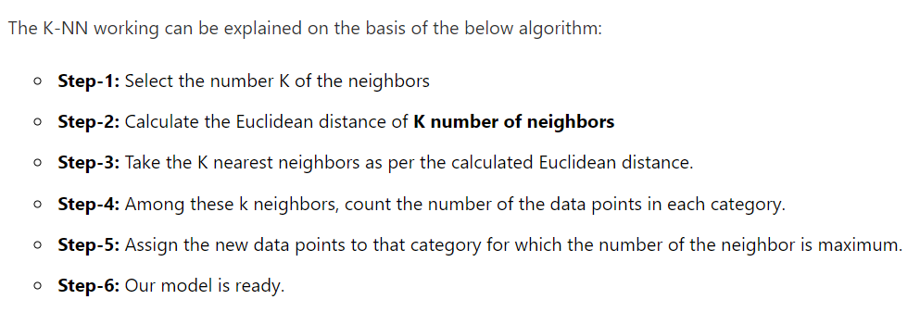

The parameters offered by sklearn.neighbors.KNeighborsClassifier are :-

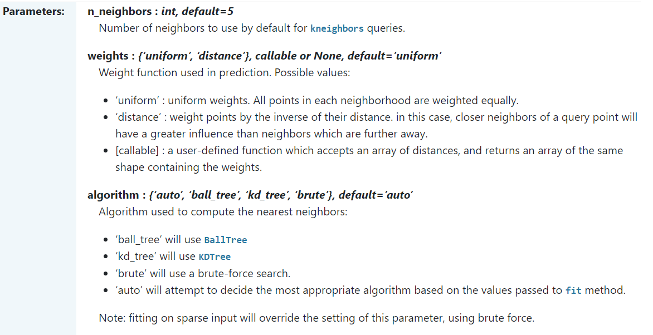

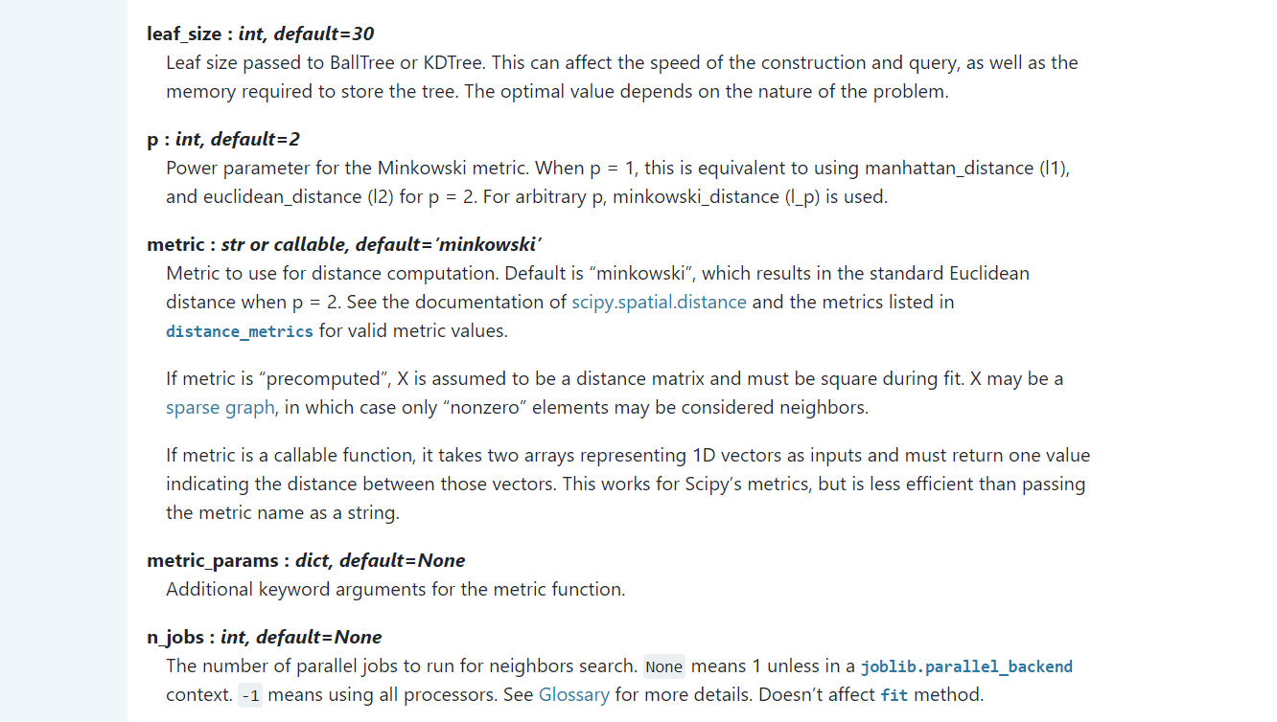

## Architecture



The n_neighbors parameter determines the value of K. We have taken the value of n_neighbors = 6, as the total number of categories (Sleep Stages) is 5. The weights = ‘distance’ sets the criteria for selecting the K nearest neighbours as Euclidean Distance. The algorithm = ‘ball_tree’ sets the algorithm as Ball Tree algorithm. Setting all other parameters as default.

This architecture gives the best results in the KNN Classifier.

## Classification Report

## 